HEALTH DISCIPLINE
CLIENT RISK ASSESSMENT FORM − Page 1
Client Name: Seton Health Alliance
Lead Recognized Professional: Holly Moore | Principal: Shea Parkes
Type of Client Entity
Governmental/public (Type:_______________________________________) |  |  | Yes No
Core business is risk-taking (Type:__________________________________) |  |  | Yes No
Stock company or other for-profit:  Publicly traded (Stock exchange listing:___________________________)  Subsidiary (Parent:___________________________________________)  Other (Description:___________________________________________)  Non-profit or other (Type: Non-profit health network_____________________________ ) |  |  | Yes No  Yes No  Yes No  Yes No
Screening and Risk Assessment Questions
(a) Is there evidence of a questionable background or history associated with either the owners (for stock companies, other than publicly traded corporations) or the management/trustees? This includes criminal or other questionable backgrounds, association with prior bankruptcies, history of being sued in connection with business / financial practices, or lack of experience or competence in the field.  - Is the company currently experiencing bad publicity? |  |  | NA⁽¹⁾ No Other
- Financial stability and capitalization:  - Existing entity: Has the company been financially unstable, does it currently operate with inadequate capital/surplus, or can it otherwise be reasonably expected to face a precarious financial position?  - Is the company growing quickly?  - Is the company in merger talks?  - Is the company expanding into a new market or offering a new product line?  - Start-up: Is the company inadequately capitalized or can it otherwise be reasonably expected to face a precarious financial position? |  |  | NA⁽²⁾ No Other
- Is the entity currently, or has it been within the past five years, under court or regulatory oversight? |  |  | NA⁽²⁾ No Other
- If the work involves an actuarial statement of opinion for a regulatory filing, did the previous actuary depart involuntarily or indicate any concerns regarding reserve levels, process, etc.? |  |  | NA⁽³⁾ No Other
- Is there a history of suing professionals or evidence of litigiousness, based on the information obtained through client screening or conflict checking?  - Are there any concerns regarding the circumstances surrounding the contact with the potential client?  - Are Milliman’s contacts at a lower level in the organizational structure and require significant oversight from other individuals higher up in the company structure?  - Does the client have unreasonable expectations concerning deadlines, data quality, and use of work product?  - Are there any unusual balance sheet or income statement items that are of concern? |  |  | No Other  No Other  No Other  No Other  No Other
- Mark “NA” only if the client being screened is a governmental / public entity.
- Mark “NA” only if the core business of the client being screened is not risk-taking.
- Mark “NA” only if work does not involve an actuarial statement of opinion for a regulatory filing.

FORWARD COPY OF SIGNED FORM TO CORPORATE LEGAL STAFF
(include copy of terms and conditions, if a “Conditioned Acceptance”)
HEALTH DISCIPLINE
CLIENT RISK ASSESSMENT FORM − Page 2

Client Name: Seton Health Alliance

Client Risk Assessment Statement

1. Standard Acceptance − I have undertaken a risk assessment of this client, and affirm that:

(a) Client screening has been completed by Milliman corporate staff, no material adverse findings are present, and the screening results are documented in the files;

(b) Answers to Screening and Risk Assessment Questions (a) – (i) on Page 1 are all “NA” or “No”;

(c) Sufficient information to make this risk assessment has been assembled and is documented in the
files; and

(d) I have assessed the risk to Milliman of this client by considering all pertinent information available, and I am not aware of any factors that would create material adverse risk to the Firm.

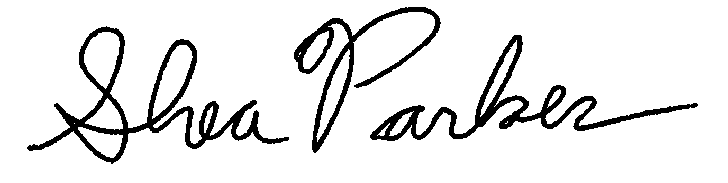 |  | 2020-04-07
Principal Date
2. Non-Acceptance − I have undertaken a risk assessment of this client, and based on those results have declined or chosen not to pursue an engagement.

Principal Date
3. Conditioned Acceptance − I have undertaken a risk assessment of this client, and affirm that:

(a) Client screening has been completed by Milliman corporate staff, the screening results have been
provided to the Health Practice Director, and they are documented in the files;

(b) A comprehensive written explanation addressing each of the Screening and Risk Assessment
Questions (a) – (i) for which the answer is “Other” has been provided to the Health Practice
Director and is documented in the files;

(c) Sufficient information to make this risk assessment has been assembled, such material has been
provided to the Health Practice Director, and it is documented in the files;

(d) The client is willing to accept all standard provisions of Milliman’s CSA (or alternative
wording and provisions acceptable to the Health Practice Director and either the ERC or Board,
whichever is appropriate, under the circumstances of a “qualified acceptance”);

(e) I have assessed the risk to Milliman of this client by considering all pertinent information available, recognize that certain adverse risk factors are or may be present, and believe that they can be adequately managed; and

(f) I have received written permission from the Health Practice Director to accept the client, with
accompanying terms and conditions for undertaking any engagement (copy to be attached).

Principal Date

